Big Whitefish Lake Update 2020

Provided by Big Whitefish Lake Association Produced by PLM Lake & Land Management Corp.

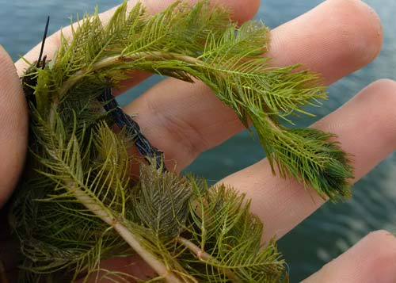
Management Goals for Big Whitefish Lake
Big Whitefish Lake is a very productive diverse aquatic ecosystem. There are many aspects to management including but not limited to exotic plants, algae control, water quality monitoring, fish habitat and native plant diversity. The primary goal of aquatic plant management in Big Whitefish Lake is the control of exotic aquatic plants. The exotic plant species, Eurasian watermilfoil and curly leaf pondweed are controlled throughout Big Whitefish Lake on a yearly basis. The abundance of these species are reduced to the maximum extent possible, and efforts are made to reduce their recovery after treatment.
Eurasian watermilfoil
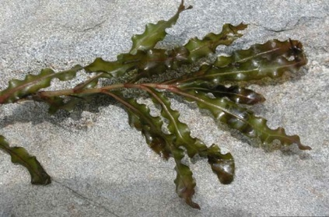
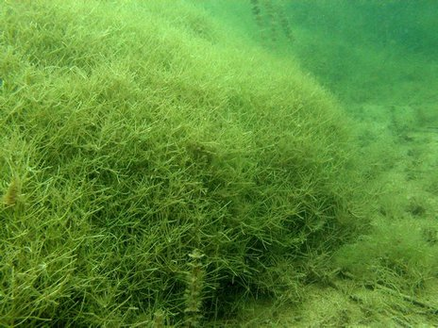
Aquatic plant management in Big Whitefish Lake seeks to preserve species diversity and cover of native plants sufficient to provide habitat for fish and other aquatic organisms. The native plant species in Big Whitefish Lake benefit the lake, performing such functions as stabilizing sediments and providing habitat for fish and other aquatic organisms. In general, native species cause fewer problems, compared with those caused by exotic plants. Currently, Big Whitefish Lake has 21 different native plant species, which include submerged, floating and emergent varieties. Native plants are managed to encourage growth that supports the Big Whitefish Lake fishery, by creating structure and habitat. At times, native plants can excessively interfere with recreational uses of the lake (e.g., swimming and fishing) in high-use areas and management may be required. Where they must be managed, techniques that reduce the stature of native plants without killing them are used whenever possible. Specific areas are set aside where native plants are not managed, to provide habitat for fish and other aquatic organisms. Muskgrass (Chara) is allowed to grow throughout the lake, except in where it grows so tall as to interfere with boating and swimming in residential areas.
Curly leaf pondweed
The species Starry stonewort (SSW), is aggressively controlled where present in Big Whitefish Lake. Starry stonewort is in the same family as Muskgrass (Chara) but is an exotic invasive species. Starry stonewort, which looks very similar to the beneficial species Chara, is appearing in more and more West Michigan lakes. Chara is a highly desired plant because it is typically low growing, keeps the water clear and can slow down the invasion of exotic weed species. Starry stonewort also forms dense mats, but unlike Chara, it can grow from 5 to 7 feet tall. Starry stonewort can be very detrimental to a lake’s ecosystem and has the ability to kill off native plants and have a negative impact on a lake’s fisheries. At the time of the 2019 year-end survey, SSW was only found in one location near the boat launch and was effectively treated.
Starry stonewort

Big Whitefish Lake Water Quality
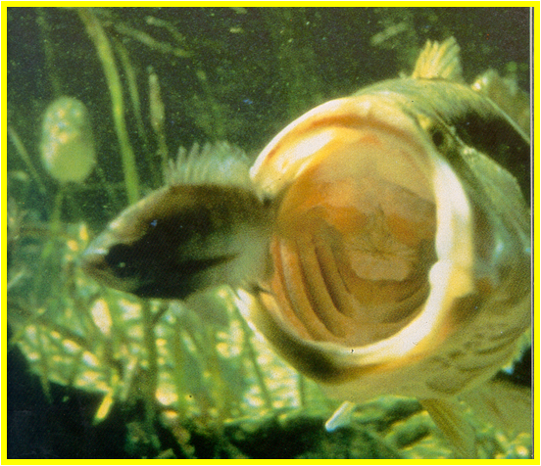
Water quality monitoring is a critical part of lake management. Water quality monitoring provides an ongoing record of conditions in Big Whitefish Lake. Changes in water quality can indicate threats from sources such as failed or inadequate septic systems, agricultural and lawn runoff, burgeoning development and erosion from construction sites. Prompt identification of threats to water quality make it possible to remedy them before irreversible harm has been done. Riparian’s enjoyment of the water resource and the value of their property depend on maintaining water quality. PLM has been monitoring the water quality of Big Whitefish Lake for over twenty years. Parameters that are evaluated every season include but are not limited to; temperature, dissolved oxygen, water clarity, E. coli, total phosphorus and nitrates concentrations.

Overall, Big Whitefish Lake has excellent water quality and supports a healthy fisheries. Nutrient enrichment of the lake is low to moderate, with elevated phosporus concentrations coming from both internal (sediments) & external sources (surrounding watershed). Water clarity is also an important factor in achieving a balanced ecosystem. The clearer the water the more sunlight that can penetrate, promoting native plant growth. Big Whitefish Lake has very good clarity with average depth of 5+ meters in the spring.

Permitting & Treatment Limitations
PLM is required to obtain a permit from the Michigan Department of Environment, Great Lakes & Energy (EGLE) for any treatments conducted on the Big Whitefish Lake. The permit outlines where treatments can take place within the lake as well as what type of herbicides can be used. EGLE also has a set of general rules that are in place for all waterbodies across the state. Some of these rules impact the way PLM treats and manages Big Whitefish Lake. Some but not all of these rules and/or limitations are explained below.
- Native Plant Control: EGLE allows for treatments of native plants. However, PLM can only treat a maximum of 100 feet per residential property. Also, native plant control is limited to water less than 5 feet deep and no greater than 300 feet from shore for the 2020 season.
- Algae Treatments: EGLE allows for filamentous and macro-algae control. However, treatments are limited to one time every 2 weeks. Also, PLM is only allowed to treat in developed shorelines out to 5 feet of water depth or 300 feet offshore, whichever comes first for the 2020 season.
- Exotic Plant Control: EGLE is much more flexible when it comes to exotic plant control. Exotic plants can be treated essentially any place where found. However, there are some limitations when it comes to the types of herbicides that can be used (systemic and/or contact). Contact herbicides for the control of Milfoil or Curlyleaf pondweed can be used one time only (offshore in areas greater than 5 feet of water) prior to June 15th. After June 15th, only systemic herbicides can be used offshore.
- NEW 100-foot Rule: Beginning in 2021, treatments for native plants and algae will be limited to a maximum of 100 ft x 100 ft per residential property. The old rule allowed for treatments out to 300 feet as long as the water depth was less than 5 feet. This change will reduce the potential treatment area on several area of Big Whitefish Lake.

Big Whitefish Lake Management Plan for 2020
The 2020 aquatic plant management program will detect and treat any areas where Eurasian watermilfoil is found, control curly leaf pondweed, control any SSW, and control any areas where native plants become sufficiently dense to interfere with recreation (if requested). Areas of excessive filamentous algal growth will be controlled using copper-based algaecides. Chara will only be controlled where it interferes in boating and swimming activities (if requested).
The product SeClear will be used for algae management on the lake. SeClear is one of the first algaecide and water quality enhancers in one, designed to replace routine algaecide programs. SeClear provides effective control of a broad-range of algae species while reducing in-water phosphorus levels with each application. SeClear uses nutrient locking technology to bind phosphorus in the water, thus removing it from the water column. Once bound, it is unavailable for algae growth. It can therefore treat the symptoms and the root cause of algae growth.
Aquatic vegetation and water quality will be monitored to document the condition of the lake and to provide warning of any changes in the condition of the lake that need to be addressed by additional lake management activities.

Big Whitefish Lake Residential Questions and/or Concerns
Big Whitefish Lake residents who have any questions regarding the overall health of the lake or lake management activities are encouraged to attend the Big Whitefish Lake Association meetings. These meetings are public and all residents are welcome. If you cannot attend the meeting and have questions or concerns, please feel free to reach out to board members or PLM Lake and Land Management for assistance.

